PROJECT PLANNING PHASE

AI FAQ ASSISTANT API

Sprint Planning & Estimation Document

Date | 15 February 2025
Team ID | SWTID-2026-9625
Project Name | AI FAQ Assistant API
Maximum Marks | 5 Marks
Project Duration | 20 September 2026 – 26 September 2026

Team Details
Team Leader | Dharshini U
Team Member | Jaya Sri G
Team Member | Priya Dharshini B
Team Member | Jasmine A H

1. Product Backlog, Sprint Schedule and Estimation
The AI FAQ Assistant API development is planned using an Agile sprint-based approach. The project is divided into four sprints so that authentication, FAQ management, AI functionality, search, security, feedback, and testing can be developed in an organized sequence. Each backlog item includes the Sprint, Functional Requirement/Epic, User Story Number, User Story/Task, Story Points, Priority, and Team Members.

Sprint-1

 | Sprint |  | Functional Requirement (Epic) |  | USN |  | User Story / Task |  |  | Points |  | Priority | Team Members
 | Sprint-1 |  | Authentication |  | USN-1 |  | As a user, I can register for the application using my name, email and password. |  |  | 3 |  | High | Dharshini U
 | Sprint-1 |  | Authentication |  | USN-2 |  | As a user, I can log into the application using my email and password. |  |  | 2 |  | High | Dharshini U
 | Sprint-1 |  | Authentication |  | USN-3 |  | As a user, I can access protected APIs using JWT authentication. |  |  | 3 |  | High | Dharshini U
 | Sprint-1 |  | User Management |  | USN-4 |  | As an administrator, I can manage users and their roles. |  |  | 2 |  | High | Dharshini U
 | Sprint-1 |  | RBAC |  | USN-5 |  | As a system, I can restrict API access according to Admin, Content Creator and User roles. |  |  | 2 |  | High | Dharshini U
 | Sprint-1 |  | Backend Setup |  | USN-6 |  | As a developer, I can organize the backend using MVC architecture. |  |  | 2 |  | High | Dharshini U
 | Sprint-1 |  | Database |  | USN-7 |  | As a system, I can connect and store application data using MongoDB Atlas. |  |  | 3 |  | High | Dharshini U
 | Sprint-1 |  | API Testing |  | USN-8 |  | As a developer, I can test the authentication APIs using Postman. |  |  | 3 |  | Medium | Dharshini U
 | Sprint-1 Total |  |  |  |  |  |  |  |  | 20
Sprint |  | Functional Requirement (Epic) |  | USN |  | User Story / Task |  | Points | Priority |  | Team Members
Sprint-1 |  | Authentication |  | USN-1 |  | As a user, I can register for the application using my name, email and password. |  | 3 | High |  | Jaya Sri G
Sprint-1 |  | Authentication |  | USN-2 |  | As a user, I can log into the application using my email and password. |  | 2 | High |  | Jaya Sri G
Sprint-1 |  | Authentication |  | USN-3 |  | As a user, I can access protected APIs using JWT authentication. |  | 3 | High |  | Jaya Sri G
Sprint-1 |  | User Management |  | USN-4 |  | As an administrator, I can manage users and their roles. |  | 2 | High |  | Jaya Sri G
Sprint-1 |  | RBAC |  | USN-5 |  | As a system, I can restrict API access according to Admin, Editor, Author and Reader roles. |  | 2 | High |  | Jaya Sri G
Sprint-1 |  | Backend Setup |  | USN-6 |  | As a developer, I can organize the backend using MVC architecture. |  | 2 | High |  | Jaya Sri G
Sprint-1 |  | Database |  | USN-7 |  | As a system, I can connect and store application data using MongoDB Atlas. |  | 3 | High |  | Jaya Sri G
Sprint-1 |  | API Testing |  | USN-8 |  | As a developer, I can test the authentication APIs using Postman. |  | 3 | Medium |  | Jaya Sri G
Sprint-1 Total |  |  |  |  |  |  |  | 20

Sprint-2

Sprint | Functional Requirement (Epic) | USN | User Story / Task | Points | Priority | Team Members
Sprint-1 | Authentication | USN-1 | As a user, I can register for the application using my name, email and password. | 3 | High | Dharshini U
Sprint-1 | Authentication | USN-2 | As a user, I can log into the application using my email and password. | 2 | High | Dharshini U
Sprint-1 | Authentication | USN-3 | As a user, I can access protected APIs using JWT authentication. | 3 | High | Jaya Sri G
Sprint-1 | User Management | USN-4 | As an administrator, I can manage users and their roles. | 2 | High | Jaya Sri G
Sprint-1 | RBAC | USN-5 | As a system, I can restrict API access according to Admin, Content Creator and User roles. | 2 | High | Dharshini U
Sprint-1 | Backend Setup | USN-6 | As a developer, I can organize the backend using MVC architecture. | 2 | High | Jaya Sri G
Sprint-1 | Database | USN-7 | As a system, I can connect and store application data using MongoDB Atlas. | 3 | High | Dharshini U
Sprint-1 | API Testing | USN-8 | As a developer, I can test the authentication APIs using Postman. | 3 | Medium | Jaya Sri G
Sprint-1 Total |  |  |  | 20

Sprint-3

Sprint | Functional Requirement (Epic) | USN | User Story / Task | Points | Priority | Team Members
Sprint-3 | AI FAQ Generation | USN-17 | As a Content Creator, I can generate FAQ content from a topic using Google Gemini. | 5 | High | Jaya Sri G
Sprint-3 | AI Question Answering | USN-18 | As a User, I can get an answer to a question using Google Gemini. | 3 | High | Jaya Sri G
Sprint-3 | Prompt Engineering | USN-19 | As a system, I can use structured prompts to generate consistent AI FAQ output. | 3 | High | Jaya Sri G
Sprint-3 | Keyword Search | USN-20 | As a user, I can search FAQs using keywords. | 3 | High | Jaya Sri G
Sprint-3 | FAQ Discovery | USN-21 | As a user, I can discover FAQs using categories and tags. | 3 | High | Jaya Sri G
Sprint-3 | Feedback Management | USN-22 | As a user, I can provide feedback on FAQ or AI-generated answers. | 3 | High | Jaya Sri G
Sprint-3 Total |  |  |  | 20

Sprint-4

Sprint | Functional Requirement (Epic) | USN | User Story / Task | Points | Priority | Team Members
Sprint-4 | Security | USN-23 | As a system, I can validate and sanitize incoming API requests. | 3 | High | Dharshini U
Sprint-4 | Security | USN-24 | As a system, I can limit excessive API requests using rate limiting. | 2 | Medium | Dharshini U
Sprint-4 | Testing | USN-25 | As a developer, I can test all major APIs through Postman and automated tests. | 3 | High | Dharshini U
Sprint-4 | Documentation | USN-26 | As a developer, I can prepare technical documentation and project demonstration material. | 2 | Medium | Dharshini U
Sprint-4 | Final Integration | USN-27 | As a system, I can integrate authentication, FAQ management, AI, search, and feedback into one backend application. | 2 | High | Dharshini U
Sprint-4 Total |  |  |  | 12

2. Sprint Summary

Sprint | Total Story Points | Duration | Planned Start Date | Planned End Date
Sprint-1 | 20 | 2 Days | 20 Sep 2026 | 21 Sep 2026
Sprint-2 | 20 | 2 Days | 22 Sep 2026 | 23 Sep 2026
Sprint-3 | 20 | 2 Days | 24 Sep 2026 | 25 Sep 2026
Sprint-4 | 12 | 1 Day | 26 Sep 2026 | 26 Sep 2026
Note: Only the overall project window (20–26 September 2026) was provided. The four sprints have been fitted sequentially into this 7-day span rather than the original 6-day/sprint template estimate. Adjust individual sprint boundaries if your course requires the literal 6-day durations.
3. Project Tracker

Sprint | Total Story Points | Duration | Start Date | End Date | Story Points Completed | Release Date
Sprint-1 | 20 | 2 Days | 20 Sep 2026 | 21 Sep 2026 | 20 | 21 Sep 2026
Sprint-2 | 20 | 2 Days | 22 Sep 2026 | 23 Sep 2026 | 20 | 23 Sep 2026
Sprint-3 | 20 | 2 Days | 24 Sep 2026 | 25 Sep 2026 | 20 | 25 Sep 2026
Sprint-4 | 12 | 1 Day | 26 Sep 2026 | 26 Sep 2026 | 12 | 26 Sep 2026
4. Velocity
Velocity represents the number of story points planned or completed during a sprint.
Sprint | Planned Story Points Remaining
Start | 72
After Sprint-1 | 52
After Sprint-2 | 32
After Sprint-3 | 12
After Sprint-4 | 0

5. Burndown Chart Data
The burndown chart represents the amount of work remaining against the progress of the project — a graphical representation of work left to complete versus time.

Sprint | Planned Story Points Remaining
Start | 80
After Sprint-1 | 60
After Sprint-2 | 40
After Sprint-3 | 20
After Sprint-4 | 0
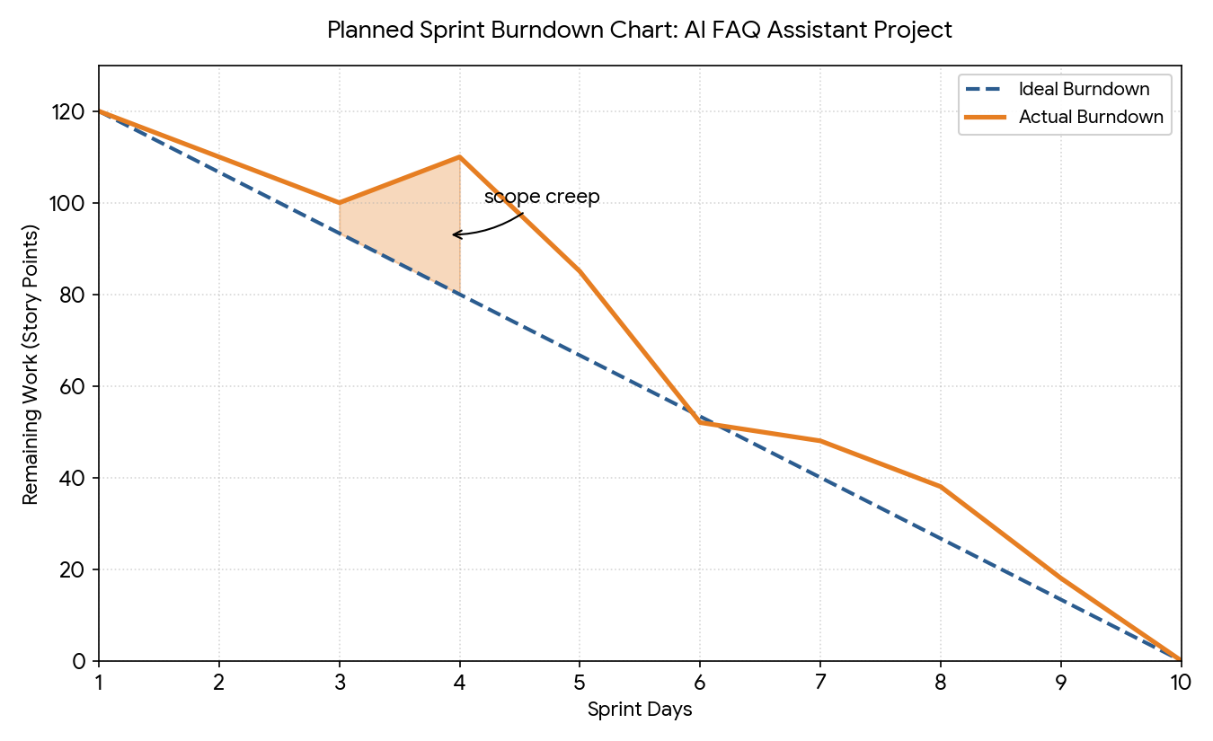
Figure 1: AI FAQ Assistant-planned sprint burndown chart

AI FAQ Assistant— Project Planning Phase — Team SWTID-2026-6999

